Unit 3- Inferential statistics and Regression

3.1 What is Normal Distribution?

A normal distribution is the continuous probability distribution with a probability density function that is represented by a symmetrical bell curve. Simply put, it is a plot of the probability function of a variable that has maximum data concentrated around one point and a few points taper off symmetrically towards two opposite ends.
In this definition of a normal distribution, you will explore the following terms:
- Continuous Probability Distribution: A probability distribution where the random variable, X, can take any given value, e.g., amount of rainfall. You can record the rainfall received at a certain time as 9 inches. But this is not an exact value. The actual value can be 9.001234 inches or an infinite amount of other numbers. There is no definitive way to plot a point in this case, and instead, you use a continuous value.
- Probability Density Function: An expression that is used to define the range of values that a continuous random variable can take.
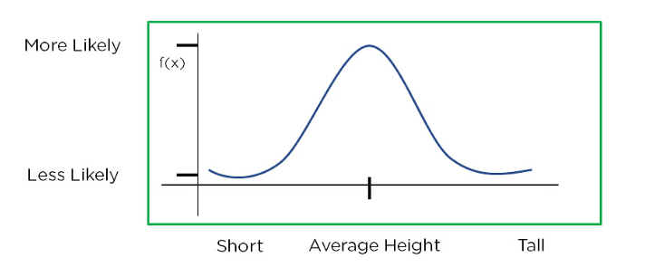
A normal distribution has a probability distribution that is centered around the mean. This means that the distribution has more data around the mean. The data distribution decreases as you move away from the center. The resulting curve is symmetrical about the mean and forms a bell-shaped distribution. Consider the below graph which shows the probability distribution of heights in a class:

Figure 1: Normal Distribution
From the above graph, you can see that the distribution is mostly about the mean or the average of all heights. Apart from this, most data is around the mean. As you move away, the probability density decreases too. This kind of curve is called a Bell Curve, and it is a common feature of a normal distribution.

Normal Distribution Definition

We define Normal Distribution as the probability density function of a continuous random variable for any given system. Let f(x) be the probability density function for any random variable X. If the function is integrated between the interval, (x, {x + dx}) giving the probability of X by considering the values between x and x+dx, and if
f(x) ≥ 0 ∀ x ϵ (−∞,+∞)
and
₋∞∫⁺∞ f(x) = 1,
then the function f(x) is the normal distribution of X.

Normal Distribution Formula

The probability density function of normal or gaussian distribution is given by;

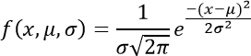

Where,

    - x is the variable
    - μ is the mean
    - σ is the standard deviation

Normal Distribution Curve

The random variables following the normal distribution are those whose values can find any unknown value in a given range. For example, finding the height of the students in

the school. Here, the distribution can consider any value, but it will be bounded in the range say, 0 to 6ft. This limitation is forced physically in our query.
Whereas, the normal distribution doesn‘t even bother about the range. The range can also extend to –∞ to + ∞ and still we can find a smooth curve. These random variables are called Continuous Variables, and the Normal Distribution then provides here probability of the value lying in a particular range for a given experiment. Also, use the normal distribution calculator to find the probability density function by just providing the mean and standard deviation value.

Normal Distribution Standard Deviation

Generally, the normal distribution has any positive standard deviation. We know that the mean helps to determine the line of symmetry of a graph, whereas the standard deviation helps to know how far the data are spread out. If the standard deviation is smaller, the data are somewhat close to each other and the graph becomes narrower. If the standard deviation is larger, the data are dispersed more, and the graph becomes wider. The standard deviations are used to subdivide the area under the normal curve. Each subdivided section defines the percentage of data, which falls into the specific region of a graph.
Using 1 standard deviation, the Empirical Rule states that,

    - Approximately 68% of the data falls within one standard deviation of the mean. (i.e., Between Mean- one Standard Deviation and Mean + one standard deviation)
    - Approximately 95% of the data falls within two standard deviations of the mean. (i.e., Between Mean- two Standard Deviation and Mean + two standard deviations)
    - Approximately 99.7% of the data fall within three standard deviations of the mean. (i.e., Between Mean- three Standard Deviation and Mean + three standard deviations)

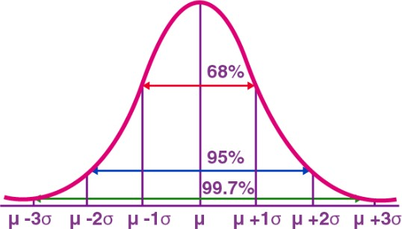

Thus, the empirical rule is also called the 68 – 95 – 99.7 rule.

Normal Distribution Problems and Solutions

Question 1: Calculate the probability density function of normal distribution using the following data. x = 3, μ = 4 and σ = 2.
Solution: Given, variable, x = 3 Mean = 4 and
Standard deviation = 2

By the formula of the probability density of normal distribution, we can write;
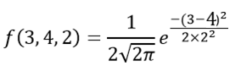

Hence, f(3,4,2) = 0.176.

Question 2: If the value of random variable is 2, mean is 5 and the standard deviation is 4, then find the probability density function of the gaussian distribution.
Solution: Given,

Variable, x = 2 Mean = 2 and
Standard deviation = 4

By the formula of the probability density of normal distribution, we can write;

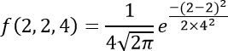

f(2,2,4) = 1/(4√2π) e⁰

f(2,2,4) = 0.0997

There are two main parameters of normal distribution in statistics namely mean and standard deviation. The location and scale parameters of the given normal distribution can be estimated using these two parameters.

Normal Distribution Properties

Some of the important properties of the normal distribution are listed below:

    - In a normal distribution, the mean, median and mode are equal.(i.e., Mean = Median= Mode).
    - The total area under the curve should be equal to 1.
    - The normally distributed curve should be symmetric at the centre.
    - There should be exactly half of the values are to the right of the centre and exactly half of the values are to the left of the centre.
    - The normal distribution should be defined by the mean and standard deviation.
    - The normal distribution curve must have only one peak. (i.e., Unimodal)

    - The curve approaches the x-axis, but it never touches, and it extends farther away from the mean.

Applications

The normal distributions are closely associated with many things such as:

    - Marks scored on the test
    - Heights of different persons
    - Size of objects produced by the machine
    - Blood pressure and so on.

Standard Normal Distribution

    - The standard normal distribution is one of the forms of the normal distribution. It occurs when a normal random variable has a mean equal to zero and a standard deviation equal to one. In other words, a normal distribution with a mean 0 and standard deviation of 1 is called the standard normal distribution. Also, the standard normal distribution is centred at zero, and the standard deviation gives the degree to which a given measurement deviates from the mean.
    - The random variable of a standard normal distribution is known as the standard score or a z-score. It is possible to transform every normal random variable X into a z score using the following formula:
•

z = (X – μ) / σ

    - where X is a normal random variable, μ is the mean of X, and σ is the standard deviation of X. You can also find the normal distribution formula here. In probability theory, the normal or Gaussian distribution is a very common continuous probability distribution.

Example: Calculate the standard deviation and z score of the ages of a population with the following ages: 25, 30, 35, 40, 45.
Ans:

Step 1: Calculate the mean and standard deviation.
Mean = (25 + 30 + 35 + 40 + 45) / 5 = 175 / 5 = 35
Standard deviation = √[((25-35)^2 + (30-35)^2 + (35-35)^2 + (40-35)^2 + (45- 35)^2) / 5] ≈ 7.07
Step 2: Calculate the Z score for each data point. Z score = (Data point - Mean) / Standard deviation Z score for 25: (25 - 35) / 7.07 ≈ -1.41
Z score for 30: (30 - 35) / 7.07 ≈ -0.71
Z score for 35: (35 - 35) / 7.07 = 0
Z score for 40: (40 - 35) / 7.07 ≈ 0.71
Z score for 45: (45 - 35) / 7.07 ≈ 1.41

Therefore, the standard deviation of the ages of the population is approximately 7.07, and the Z scores for the ages of 25, 30, 35, 40, and 45 are approximately -
1.41, -0.71, 0, 0.71, and 1.41, respectively.

Standard Normal Distribution Table

The standard normal distribution table gives the probability of a regularly distributed random variable Z, whose mean is equivalent to 0 and the difference equal to 1, is not exactly or equal to z. The normal distribution is a persistent probability distribution. It is also called Gaussian distribution. It is pertinent for positive estimations of z only.
A standard normal distribution table is utilized to determine the region under the bend (f(z)) to discover the probability of a specified range of distribution. The normal distribution density function f(z) is called the Bell Curve since its shape looks like a bell.

What does it mean? Is that on the off chance that you need to discover the probability of a value is not exactly or more than a fixed positive z value. You can discover it by finding it on the table. This is known as area Φ.
A standard normal distribution table presents a cumulative probability linked with a particular z-score. The rows of the table represent the whole number and tenth place of the z-score. The columns of the table represent the hundredth place. The cumulative probability (from –∞ to the z-score) arrives in the cell of the table.
For example, a part of the standard normal table is given below. To find the cumulative probability of a z-score equal to -1.21, cross-reference the row containing -1.2 of the table with the column holding 0.01. The table explains that the probability that a standard normal random variable will be less than -1.21 is 0.1131; that is, P(Z < -1.21)
= 0.1131. This table is also called a z-score table.
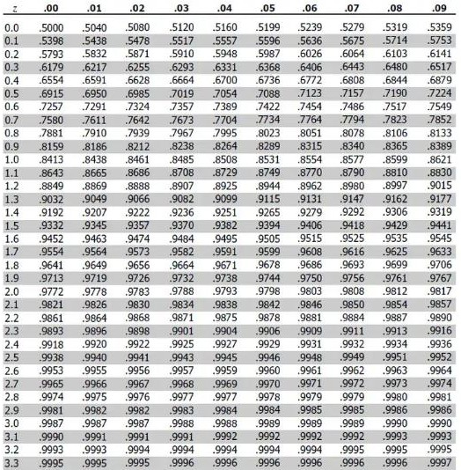

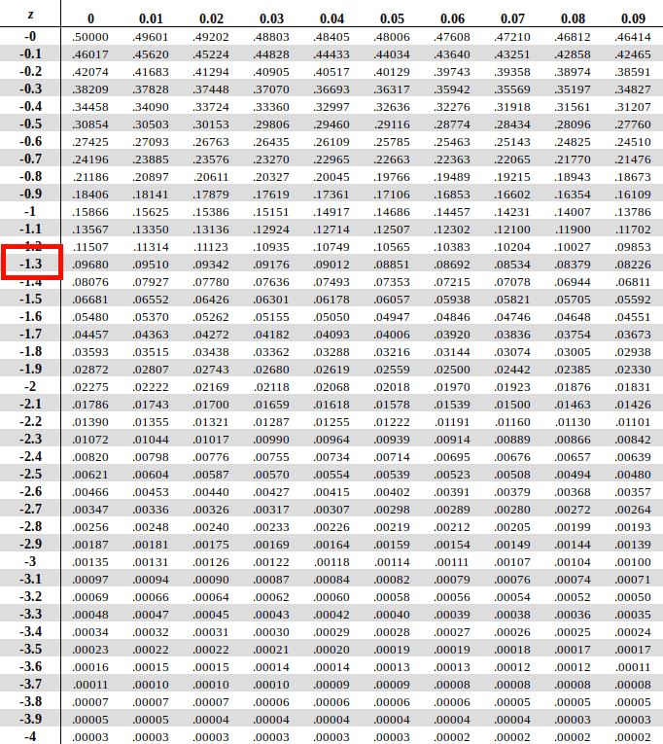

Area of Standard Normal Distribution

Diagrammatically, the probability of Z not exactly ―a‖ being Φ(a), figured from the standard normal distribution table, is demonstrated as follows:

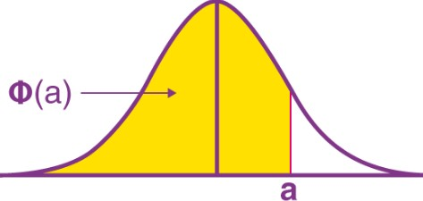

P(Z < –a)

As specified over, the standard normal distribution table just gives the probability to values, not exactly a positive z value (i.e., z values on the right-hand side of the mean). So how would we ascertain the probability beneath a negative z value (as outlined below)?
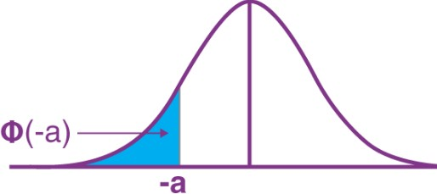

P(Z > a)

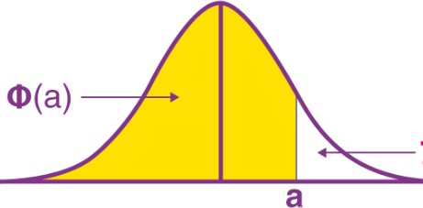
The probability of P(Z > a) is 1 – Φ(a). To understand the reasoning behind this look at

the illustration below:

You know Φ(a), and you realize that the total area under the standard normal curve is 1 so by numerical conclusion: P(Z > a) is 1 -Φ(a).

P(Z > –a)

The probability of P(Z > –a) is P(a), which is Φ(a). To comprehend this, we have to value the symmetry of the standard normal distribution curve. We are attempting to discover the region
Below:

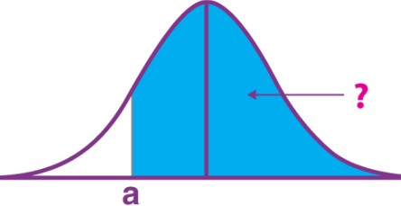

If this area is in the region we need.

Notice this is the same size area as the area we are searching for, just we know this area, as we can get it straight from the standard normal distribution table: it is
P(Z < a). In this way, the P(Z > –a) is P(Z < a), which is Φ(a).

Probability between z values

Let us find the probability between the values of z, i.e., a and b. Consider the graph given below:
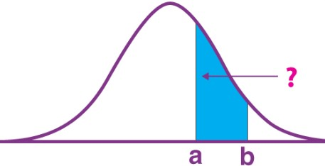

Now,

P(Z < b) – P(Z < a) = Φ(b) – Φ(a)

Thus,

P(a < Z < b) = Φ(b) – Φ(a)
Here, the values of a and b are positive. Standard Normal Distribution Function
The standard normal distribution function for a random variable x is given by:

Probability Density Function is given by the formula,

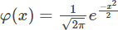

This is a special case when μ = 0 and σ = 1. This situation of a normal distribution is also called the standard normal distribution or unit normal distribution.

Cumulative Distribution Function

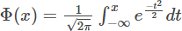
The cumulative distribution function (CDF) of the standard normal distribution is generally denoted with the capital Greek letter Φ and is given by the formula:

Standard Normal Distribution Uses

    - The standard normal distribution is a tool to translate a normal distribution into numbers. We may use it to get more information about the data set than was initially known.
    - Standard normal distribution allows us to quickly estimate the probability of specific values befalling in our distribution or compare data sets with varying means and standard deviations.
    - Also, the z-score of the standard normal distribution is interpreted as the number of standard deviations a data point falls above or below the mean.

Characteristics of Standard Normal Distribution

A z-score of a standard normal distribution is a standard score that indicates how many standard deviations are away from the mean an individual value (x) lies:

    - When z-score is positive, the x-value is greater than the mean
    - When z-score is negative, the x-value is less than the mean
    - When z-score is equal to 0, the x-value is equal to the mean
The empirical rule, or the 68-95-99.7 rule of standard normal distribution, tells us where most values lie in the given normal distribution. Thus, for the standard normal distribution, 68% of the observations lie within 1 standard deviation of the mean; 95% lie within two standard deviations of the mean; 99.7% lie within 3 standard deviations of the mean.

Standard Normal Distribution Problem and Solution

Problem 1: For some computers, the time period between charges of the battery is normally distributed with a mean of 50 hours and a standard deviation of 15 hours. Rohan has one of these computers and needs to know the probability that the time period will be between 50 and 70 hours.

Solution: Let x be the random variable that represents the time period.

Given Mean, μ= 50

and standard deviation, σ = 15

To find: Pprobability that x is between 50 and 70 or P( 50< x < 70) By using the transformation equation, we know;
z = (X – μ) / σ

For x = 50 , z = (50 – 50) / 15 = 0

For x = 70 , z = (70 – 50) / 15 = 1.33

P( 50< x < 70) = P( 0< z < 1.33) = [area to the left of z = 1.33] – [area to the left of z = 0]
From the table we get the value, such as; P( 0< z < 1.33) = 0.9082 – 0.5 = 0.4082
The probability that Rohan‘s computer has a time period between 50 and 70 hours is equal to 0.4082.

Problem 2: The speeds of cars are measured using a radar unit, on a motorway. The speeds are normally distributed with a mean of 90 km/hr and a standard deviation of 10 km/hr. What is the probability that a car selected at chance is moving at more than 100 km/hr?
Solution: Let the speed of cars is represented by a random variable ‗x‘. Now, given mean, μ = 90 and standard deviation, σ = 10.

To find: Probability that x is higher than 100 or P(x > 100) By using the transformation equation, we know;
z = (X – μ) / σ

Hence,

For x = 100 , z = (100 – 90) / 10 = 1

P(x > 90) = P(z > 1) = [total area] – [area to the left of z = 1] P(z > 1) = 1 – 0.8413 = 0.1587

Problem 3: X is a normally distributed variable with mean μ = 30 and standard deviation σ = 4. Find the probabilities
a) P(X < 40)

b) P(X > 21)
c) P(30 < X < 35)

Solution:

a) For x = 40, the z-value z = (40 - 30) / 4 = 2.5
Hence P(x < 40) = P(z < 2.5) = [area to the left of 2.5] = 0.9938

b) For x = 21, z = (21 - 30) / 4 = -2.25 Hence P(x > 21) = P(z > -2.25)

= [total area] - [area to the left of -2.25]
= 1 - 0.0122 = 0.9878

c) For x = 30 , z = (30 - 30) / 4 = 0

and for x = 35, z = (35 - 30) / 4 = 1.25 Hence P(30 < x < 35) = P(0 < z < 1.25)

= [area to the left of z = 1.25] - [area to the left of 0]
= 0.8944 - 0.5 = 0.3944

Problem 4: Entry to a certain University is determined by a national test. The scores on this test are normally distributed with a mean of 500 and a standard deviation of 100. Tom wants to be admitted to this university and he knows that he must score better than at least 70% of the students who took the test. Tom takes the test and scores 585. Will he be admitted to this university?

Solution: Let x be the random variable that represents the scores.

x is normally distributed with a mean of 500 and a standard deviation of 100.

The total area under the normal curve represents the total number of students who took the test. If we multiply the values of the areas under the curve by 100, we obtain percentages.

For x = 585 , z = (585 - 500) / 100 = 0.85

The proportion P of students who scored below 585 is given by

P = [area to the left of z = 0.85] = 0.8023 = 80.23%

Tom scored better than 80.23% of the students who took the test and he will be admitted to this University.

Problem 5: The length of similar components produced by a company is approximated by a normal distribution model with a mean of 5 cm and a standard deviation of 0.02 cm. If a component is chosen at random
- what is the probability that the length of this component is between 4.98 and

5.02 cm?
- What is the probability that the length of this component is between 4.96 and

5.04 cm?

Solution:

a) P(4.98 < x < 5.02) = P(-1 < z < 1)
= 0.6826
b) P(4.96 < x < 5.04) = P(-2 < z < 2)
= 0.9544

Problem 6: What is the area associated with the Z-score 1.62?
The standard normal table and associated area for z = 1.62. Step1: Reading the Standard Normal Table
Read down the Z-column to get the first part of the Z-score (1.6).
Read across the top row to get the second decimal place in the Z-score (0.02).
The intersection of this row and column gives the area under the curve to the left of the Z-score.

Step2: Finding Z-scores for a Given Area
What if we have an area and we want to find the Z-score associated with that

area?

Instead of Z-score → area, we want area → Z-score.
We can use the standard normal table to find the area in the body of values and

read backwards to find the associated Z-score.

Using the table, search the probabilities to find an area that is closest to the probability you are interested in.

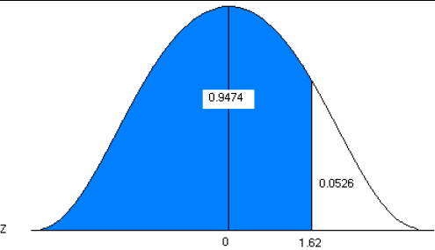

Problem 7: Find a Z-score for which the area to the right is 5%.
Since the table is cumulative from the left, you must use the complement of 5%.
1– 0.05 = 0.9500

Step1: Find the Z-score for the area of 0.9500.
Look at the probabilities and find a value as close to 0.9500 as possible. The Z-score for the 95th percentile is 1.64

Problem 8.Find Z-scores that limit the middle 95%
The middle 95% has 2.5% on the right and 2.5% on the left. Use the symmetry of the curve.
Look at your standard normal table. Since the table is cumulative from the left, it is easier to find the area to the left first.
Find the area of 0.025 on the negative side of the table. The Z-score for the area to the left is -1.96.

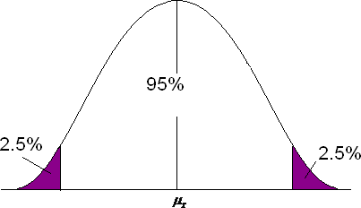

Since the curve is symmetric, the Z-score for the area to the right is 1.96. Common Z-scores
There are many commonly used Z-scores:
Z.05 = 1.645 and the area between -1.645 and 1.645 is 90%
Z.025 = 1.96 and the area between -1.96 and 1.96 is 95%
Z.005 = 2.575 and the area between -2.575 and 2.575 is 99%

Central Limit Theorem

Central Limit Theorem in Statistics states that as the sample size increases and its variance is finite, then the distribution of the sample mean approaches normal distribution irrespective of the shape of the population distribution.

Central Limit Theorem Definition
Central Limit Theorem states that when large samples usually greater than thirty are taken into consideration then the distribution of sample arithmetic mean approaches the normal distribution irrespective of the fact that random variables were originally distributed normally or not.

Assumptions of Central Limit Theorem
Central Limit Theorem is valid for the following conditions:
- The drawing of the sample from the population should be random.
18

- The drawing of the sample should be independent of each other.
- The sample size should not exceed ten per cent of the total population when sampling is done without replacement.
- Sample Size should be adequately large.
- CLT only holds true for population with finite variance.

Let us assume we have a random variable X. Let σ is its standard deviation and μ is the mean of the random variable. Now as per Central Limit Theorem

The mean of the sampling distribution is the mean of the population.

The standard deviation of the sampling distribution is the standard deviation of the population divided by the square root of the sample size.
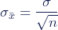

We can describe the sampling distribution of the mean using this notation:

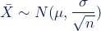

Where:

  - X̅ is the sampling distribution of the sample means
  - ~ means ―follows the distribution‖
  - N is the normal distribution
  - µ is the mean of the population
  - σ is the standard deviation of the population
  - n is the sample size

The Z-Score of the random variable is given as

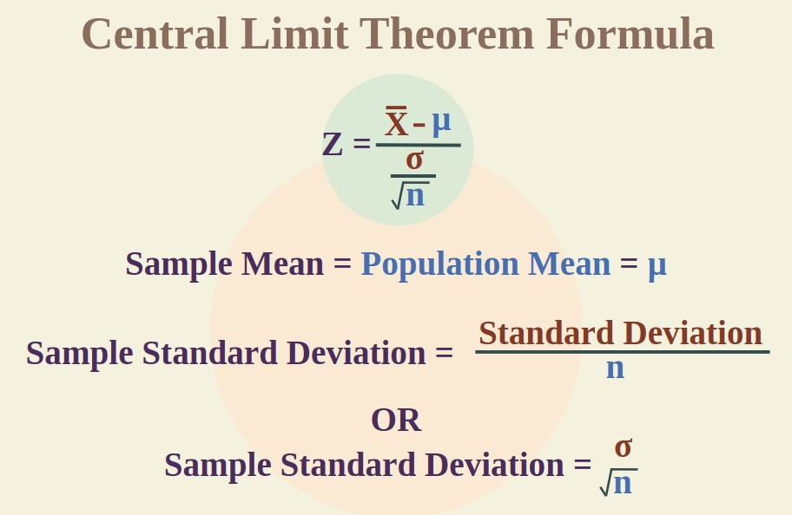

The central limit theorem is comprised of several key characteristics. These characteristics largely revolve around samples, sample sizes, and the population of data.

- Sampling is successive. This means some sample units are common with sample units selected on previous occasions.
- Sampling is random. All samples must be selected at random so that they have the same statistical possibility of being selected.
- Samples should be independent. The selections or results from one sample should have no bearing on future samples or other sample results.
- Samples should be limited. It's often cited that a sample should be no more than 10% of a population if sampling is done without replacement. In general, larger population sizes warrant the use of larger sample sizes.
- Sample size is increasing. The central limit theorem is relevant as more samples are selected.

Example 1. The male population’s weight data follows a normal distribution. It has a mean of 70 kg and a standard deviation of 15 kg. What would the mean and standard deviation of a sample of 50 guys be if a researcher looked at their records?
Solution:

Given: μ = 70 kg, σ = 15 kg, n = 50

As per the Central Limit Theorem, the sample mean is equal to the population mean.

Hence, = μ = 70 kg

Now, 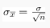= 15/√50
⇒ ≈ 2.1 kg

Example 2. A distribution has a mean of 69 and a standard deviation of 420. Find the mean and standard deviation if a sample of 80 is drawn from the distribution.
Solution:

Given: μ = 69, σ = 420, n = 80

As per the Central Limit Theorem, the sample mean is equal to the population mean.

Hence, = μ = 69

Now, = 420/√80
⇒ = 46.95

Example 3. The mean age of people in a colony is 34 years. Suppose the standard deviation is 15 years. The sample of size is 50. Find the mean and standard deviation of the sample.
Solution:

Given: μ = 34, σ = 15, n = 50

As per the Central Limit Theorem, the sample mean is equal to the population mean.

Hence, = μ = 34 years

Now, = 15/√50
⇒ σ_{x} = 2.12 years

Standard Error, Estimator & Estimate, Confidence Interval, Student T distribution, Margin of Error
Standard Error

In statistics, the standard error is the standard deviation of the sample distribution. The sample mean of a data is generally varied from the actual population mean. It is represented as SE. It is used to measure the amount of accuracy by which the given sample represents its population.
The standard error is a common measure of sampling error—the difference between a population parameter and a sample statistic.
    - A high standard error shows that sample means are widely spread around the population mean—your sample may not closely represent your population.
    - A low standard error shows that sample means are closely distributed around the population mean—your sample is representative of your population.

Standard error vs standard deviation

Standard error and standard deviation are both measures of variability:

    - The standard deviation describes variability within a single sample.
    - The standard error estimates the variability across multiple samples of a population.

The standard deviation is a descriptive statistic that can be calculated from sample data.

In contrast, the standard error is an inferential statistic that can only be estimated (unless the real population parameter is known).

Example: Standard error vs standard deviation

In a random sample of 200 students, the mean math SAT score is 550. In this case, the sample is the 200 students, while the population is all test takers in the region.
The standard deviation of the math scores is 180. This number reflects on average how much each score differs from the sample mean score of 550.

The standard error of the math scores, on the other hand, tells you how much the sample mean score of 550 differs from other sample mean scores, in samples of equal size, in the population of all test takers in the region.
Aspect | Standard Error (SE) | Standard Deviation  (SD)
Definition | Standard Error is a measure of how much the sample mean is expected to vary from the population mean. It reflects the precision of the sample mean as an estimate of the  population mean. | Standard Deviation is a measure of the spread or dispersion of data in a dataset or population. It quantifies how individual data points vary from the mean.
Formula | SE = SD / √n, where n is the sample size. | There's no direct formula to calculate standard deviation from standard error. It's  calculated separately

using the
formula: SD = √[Σ(X - μ)² / N], where X is an individual data point, μ is the population mean, and N is the population
size.
Sample Size Sensitivity |  | The standard error  decreases as the sample size (n) increases. A larger sample size leads to a smaller standard error, indicating greater  precision. | Standard deviation is  not influenced by the sample size. It remains the same regardless of the sample size.
Purpose |  | Standard Error is often  used when making inferences about the population mean based on sample data, such as in hypothesis testing and confidence interval  construction. | Standard Deviation is  used to describe the variability or dispersion of data within a dataset or population. It's used for understanding the spread of values in the  data.
Units of Measurement |  | The units of standard  error are the same as the units of the data (e.g., if the data is in inches, SE is in inches). | The units of standard  deviation are the same as the units of the data (e.g., if the data is in inches, SD is in inches).
Application Example |  | Calculating the standard  error when estimating the mean income of a | Calculating the standard  deviation of test scores in a class to understand

 | city based on a sample survey. | how much scores vary around the class  average.
Represented Symbol | SE (standard error) | SD (standard deviation)

Different formulas are used depending on whether the population standard deviation is known. These formulas work for samples with more than 20 elements (n > 20).

When population parameters are known

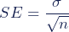
When the population standard deviation is known, you can use it in the below formula to calculate standard error precisely.

Formula | Explanation
- is standard error
- is population standard deviation
- is the number of elements in the sample

When population parameters are unknown

When the population standard deviation is unknown, you can use the below formula to only estimate standard error. This formula takes the sample standard deviation as
a point estimate for the population standard deviation.

Formula | Explanation
- is standard error
- is sample standard deviation
- is the number of elements in the sample

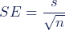
Example: In a random sample of 200 students, the mean math SAT score is 550.

The standard deviation of the math scores is 180.Using the standard error formula estimate the standard error for math SAT scores,
First, find the square root of your sample size (n).

Formula | Calculation

Next, divide the sample standard deviation by the number you found in step one.

Formula | Calculation

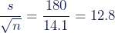

You can report the standard error alongside the mean or in a confidence interval to communicate the uncertainty around the mean.

Example: Reporting the mean and standard error The mean math SAT score of a random sample of test takers is 550 ± 12.8 (SE).

Estimator & Estimate

    - An estimator is a statistic that estimates some fact about the population. For example, the sample mean(x̅) is an estimator for the population mean, μ.
    - A point estimate is a single number, tells How much uncertainty is associated with a point estimate of a population parameter?
    - An interval estimate provides more information about a population characteristic than does a point estimate. It provides a confidence level for the estimate. Such interval estimates are called confidence intervals.
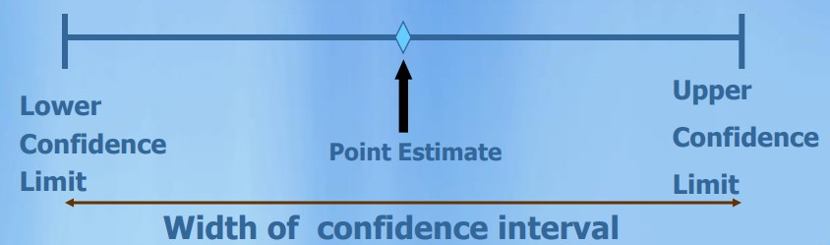

Confidence Interval

    - A confidence interval is the mean of your estimate plus and minus the variation in that estimate. This is the range of values you expect your estimate to fall between if you redo your test, within a certain level of confidence.
    - Confidence, in statistics, is another way to describe probability. For example, if you construct a confidence interval with a 95% confidence level, you are confident that 95 out of 100 times the estimate will fall between the upper and lower values specified by the confidence interval.

Your desired confidence level is usually one minus the alpha (α) value you used in your statistical test:

Confidence level = 1 − a

So if you use an alpha value of p < 0.05 for statistical significance, then your confidence level would be 1 − 0.05 = 0.95, or 95%.

There are 3 different cases:
- Interval Estimation of μ when X is normally distributed.

- Interval Estimation of μ when X is not normally distributed but the population Standard Deviation is known
- Interval Estimation of μ when X is normally distributed and the population Standard Deviation unknown

Case 1: Interval Estimation of μ when X is normally distributed
The confidence interval for data which follows a standard normal distribution is:

Where:

  - CI = the confidence interval
  - X̅ = the population mean
  - Z* = the critical value of the z distribution
  - σ = the population standard deviation
  - √n = the square root of the population size

Consider a 95% confidence interval:
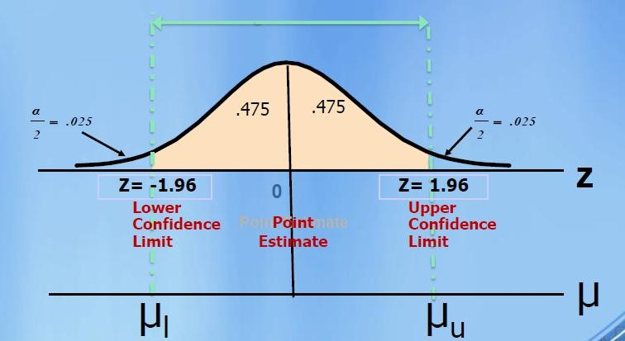

Case 2: Interval Estimation of μ when X is not normally distributed but σ is known

•If the distribution of X is not normally distributed, then the central limit theorem can only be applied loosely and we can only say that the sampling distribution is approximately normal.
•When n is greater than 30, this approximation is generally good.

•Then we use the previous formula to calculate confidence interval.
we replace the population values with the values from our sample data, so the formula becomes:

Where:

ˆx = the sample mean

s = the sample standard deviation

Case 3: Interval Estimation of μ when X is normally distributed and σ is unknown
- Nearly always σ is unknown and is estimated using sample standard deviation s.

- If population standard deviation is unknown then it can be shown that sample means from samples of size n are t-distributed with n-1 degrees of freedom.
- As an estimate for standard error we can use s/√n

Example : In a population, a random variable follows a normal distribution with an unknown mean and a standard deviation of 2.
29

- In a sample of 400 selected at random, a sample mean of 50 was obtained. Determine the confidence interval with a confidence level of 97% for the average population.
- With the same confidence level, what minimum sample size should it have so that the interval width has a maximum length of 1?

Solution:

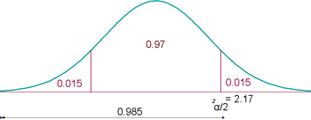

Confidence Interval =

Minimum sample size for the interval width has a maximum length of 1

Student T- Distribution Definition

The t-distribution is a hypothetical probability distribution. It is also known as the student‘s t-distribution and used to make presumptions about a mean when the population standard deviation is not known to us. It is symmetrical, bell-shaped distribution, similar to the standard normal curve. As high as the degrees of freedom (df), the closer this distribution will approximate a standard normal distribution with a mean of 0 and a standard deviation of 1.

T Distribution Formula

A t-distribution is the whole set of t values measured for every possible random sample for specific sample size or a particular degree of freedom. It approximates the shape of normal distribution.
Let x have a normal distribution with mean ‗μ‘ for the sample of size ‗n‘ with sample mean x̅ and the sample standard deviation ‗s‘, then the t variable has student‘s t- distribution with a degree of freedom, d.f = n – 1. The formula for t-distribution is given by;

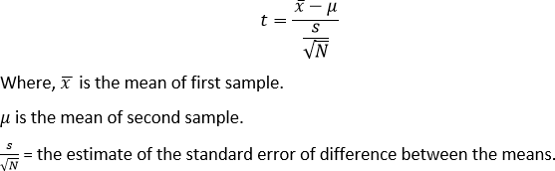

T-Distribution Table

The t-distribution table is used to determine proportions connected with z-scores. We use this table to find the ratio for t-statistics. The t-distribution table shows the probability of t taking values from a given value. The obtained probability is the area of the t-curve between the ordinates of t-distribution, the given value and infinity.
In the t-distribution table, the critical values are defined for degrees of freedom (df) to the probabilities of t-distribution, α.

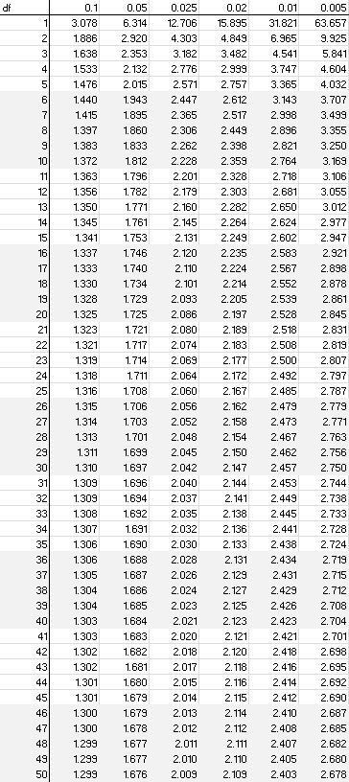

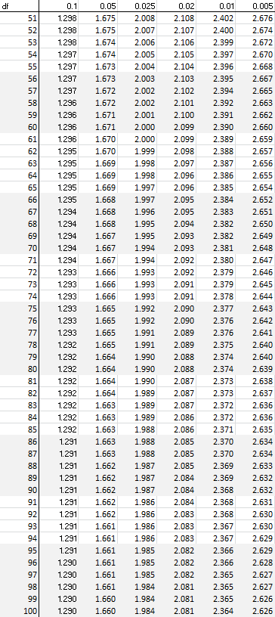

Properties of T Distribution

- It ranges from −∞ to +∞.
- It has a bell-shaped curve and symmetry similar to normal distribution.

- The shape of the t-distribution varies with the change in degrees of freedom.
- The variance of the t-distribution is always greater than ‗1‘ and is limited only to 3 or more degrees of freedom. It means this distribution has a higher dispersion than the standard normal distribution.
t-scores play a pivotal role in hypothesis testing and statistical inference. They help assess the reliability of sample statistics and guide decision-making by providing a measure of how much a sample statistic deviates from the expected population parameter. Understanding t-scores is crucial for conducting valid and reliable statistical analyses.

Suppose you are conducting an experiment to determine whether a new training program improves the performance of employees. You have a sample of 20 employees who underwent the training, and you want to compare their post-training performance to the population of all employees (with a known population mean) before the training.

Here's the information you have:
Sample mean (x̅): 75
Population mean (μ before training): 70 Sample standard deviation (s): 8 Sample size (n): 20
Calculate the t-score using the formula: t = (75 - 70) / (8 / √20)
t = (5) / (8 / √20) t ≈ 5 / (8 / 4.47)
t ≈ 5 / 1.79
t ≈ 2.79
Determine the degrees of freedom (df):
In this case, df is equal to n - 1, so df = 20 - 1 = 19.

Look up the critical t-value for a specific significance level and degrees of freedom. Let's assume you're using a significance level of 0.05 for a two-tailed test, so α =
0.05. You can find the critical t-value from a t-table or using statistical software. In this case, the critical t-value might be around 2.093 (based on a t-table).

Compare the calculated t-score (2.79) with the critical t-value (2.093):
If the calculated t-score is greater than the critical t-value, you would reject the null hypothesis (H0) and conclude that there is evidence that the training program had a statistically significant effect on employee performance.
If the calculated t-score is less than the critical t-value, you would fail to reject the null hypothesis, indicating that there is no statistically significant evidence of an effect from the training program.

Example:
20 students are selected at random from a clinical psychology class; find the probability that their mean GPA is more than 5. If the average GPA scored by the entire batch is 4.91, the standard deviation is 0.72.
Solution:
Here,
Population mean = µ = 4.91
Population standard deviation= σ = 0.72 Sample size = n = 20 (which is less than 30)
Since the sample size is smaller than 30, use the t-score instead of the z-score, even though the population standard deviation is known.
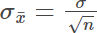

Substituting the values, we have

= 0.161

Now, find the t-score
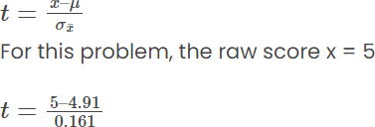
t = 0.559

Find the probability for the t value using the t-score table. The degree of freedom here would be:
Df = 20 – 1 = 19
P(t ≤ 0.559) = 0.7087
P(t > 0.559) = 1 – 0.7087 = 0.2913
Thus, the probability that the score is more than 5 is 9.13 %.

Example 2:
The average weight of a water bottle is 30 kg, with a standard deviation of 1.5 kg. If a sample of 45 water bottles is selected at random from a consignment and their weights are measured, find the probability that the mean weight of the sample is less than 28 kg.

Solution:
Population mean: µ = 30 kg
Population standard deviation: σ = 1.5 Kg Sample size: n = 45 (which is greater than 30) Using the z-score, we have
The sample standard deviation:

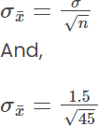

= 6.7082
Find the z-score for the raw score of x = 28 kg

= (28 – 30)(6.7082) = -0.2981

Using the z-score table P(z < -0.2981) = 0.3828
Thus, the probability that the weight of the cylinder is less than 28 kg is 38.28%.

Margin of Error

The margin of error is a statistic expressing an amount of random sampling error in a survey‘s results. It asserts a likelihood that the result from a sample is close to the number one would get if the whole population had been queried.
The margin of error (MOE) for a survey tells you how near you can expect the survey results to be to the correct population value. For example, a survey indicates that 72% of respondents favor Brand A over Brand B with a 3% margin of error. In this case, the actual population percentage that prefers Brand A likely falls within the range of 72% ± 3%, or 69 – 75%.
The margin of error is denoted by E and the formula is given as,

where,

n= sample size

σ= Population Standard Deviation z = z score
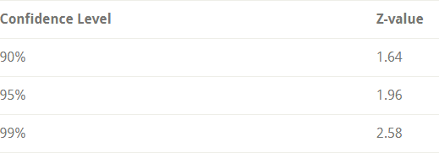

Question: A random sample of 30 students has average yearly earnings of 2450 and a standard deviation of 587. Find the margin of error if c = 0.95?

Solution:

Given
n=30, Standard Deviation= 587

σ = 587

c = 0.95

At 95% level of confidence z = 1.96 Margin of error = z × σ/√n
= 1.96 × 587/√30

= 1.96 × 107.12

= 209.96

= 210 (approx)

Linear regression

Linear regression is a type of statistical analysis used to predict the relationship between two variables. It assumes a linear relationship between the independent variable and the dependent variable, and aims to find the best-fitting line that describes the relationship. The line is determined by minimizing the sum of the squared differences between the predicted values and the actual values.

Linear regression is commonly used in many fields, including economics, finance, and social sciences, to analyze and predict trends in data.

In a simple linear regression, there is one independent variable and one dependent variable. The model estimates the slope and intercept of the line of best fit, which represents the relationship between the variables. The slope represents the change in the dependent variable for each unit change in the independent variable, while the intercept represents the predicted value of the dependent variable when the independent variable is zero. Linear regression shows the linear relationship between the independent(predictor) variable i.e. X-axis and the dependent(output) variable i.e. Y- axis, called linear regression. If there is a single input variable X(independent variable), such linear regression is called simple linear regression.
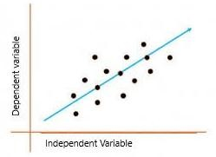

The graph above presents the linear relationship between the output(y) and predictor(X) variables. The blue line is referred to as the best-fit straight line. Based on the given data points, we attempt to plot a line that fits the points the best.

To calculate best-fit line linear regression uses a traditional slope-intercept form which is given below,

Y_{i} = β₀ + β₁X_{i}

where Y_{i} = Dependent variable, β₀ = constant/Intercept, β₁ = Slope/Intercept, X_{i} = Independent variable.

This algorithm explains the linear relationship between the dependent (output) variable y and the independent (predictor) variable X using a straight line

Y= B₀ + B₁ X.

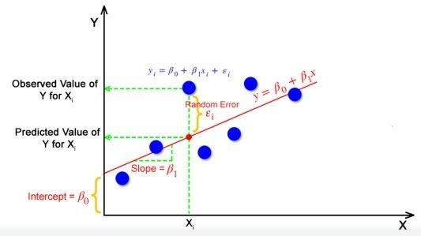

The goal of the linear regression algorithm is to get the best values for B₀ and B₁ to find the best fit line. The best fit line is a line that has the least error which means the error between predicted values and actual values should be minimum.

Random Error(Residuals)

In regression, the difference between the observed value of the dependent variable (y_{i}) and the predicted value(predicted) is called the residuals.

εi = ypredicted – yi

where ypredicted = B0 + B1 Xi Correlation Vs Regression
Correlation and Regression are the two important concepts in Statistical research, which are based on variable distribution. A variable distribution is explained as a classification/distribution of multiple variables.

Correlation is explained as an analysis which helps us to determine the absence of the relationship between the two variables – ‗p‘ and ‗q‘.
Regression is also an analysis, that foretells the value of a dependent variable based on the value that is already known of the independent variable.

Correlation | Regression
‗Correlation‘, as the name says, it determines the interconnection or a co-relationship between the variables. | ‗Regression‘ explains how an independent variable is numerically associated with the dependent variable.
In Correlation, both the independent and dependent values have no difference. | However, in Regression, both the dependent and independent variables are different.
The primary objective of Correlation is to find out a quantitative/numerical value expressing the association between the values. | Regression‘s main purpose is to calculate the values of a random variable based on the values of a fixed

 | variable.
Correlation stipulates the degree to which both variables can move together. | However, regression specifies the effect of the change in the unit in the known variable(p) on the evaluated variable (q).
Correlation helps to constitute the connection between the two variables. | Regression helps in estimating a variable‘s value based on another given value.

There are three different sum of squares values to measure how well the regression line actually fits the data:

- Sum of Squares Total (SST) – The sum of squared differences between individual data points (y_{i}) and the mean of the response variable (𝑦̅)
  - SST = Σ(y_{i} – 𝑦̅)²

- Sum of Squares Regression (SSR) – The sum of squared differences between predicted data points (ŷ_{i}) and the mean of the response variable(𝑦̅).
  - SSR = Σ(ŷ_{i} – 𝑦̅)²

- Sum of Squares Error (SSE) – The sum of squared differences between predicted data points (ŷ_{i}) and observed data points (y_{i}).
  - SSE = Σ(ŷ_{i} – y_{i})²

The following relationship exists between these three measures:

SST = SSR + SSE

Thus, if we know two of these measures then we can use some simple algebra to calculate the third.

SSR, SST & R-Squared

R-squared, sometimes referred to as the coefficient of determination, is a measure of how well a linear regression model fits a dataset. It represents the proportion of the variance in the response variable that can be explained by the predictor variable.

The value for R-squared can range from 0 to 1. A value of 0 indicates that the response variable cannot be explained by the predictor variable at all. A value of 1 indicates that the response variable can be perfectly explained without error by the predictor variable.

Using SSR and SST, we can calculate R-squared as:

R-squared =1- ( SSR / SST)

For example, if the SSR for a given regression model is 137.5 and SST is 156 then we would calculate R-squared as:
R-squared = 1- (137.5 / 156 )= 1- 0.8814= 0.1186

This tells us that 11.86 % of the variation in the response variable can be explained by the predictor variable.

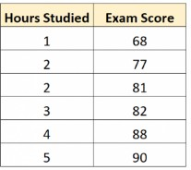
Example1: Calculate SST, SSR, SSE for the following dataset that shows the number of hours studied by six different students along with their final exam scores:

the line of best fit is Score = 66.615 + 5.0769*(Hours). Solution:
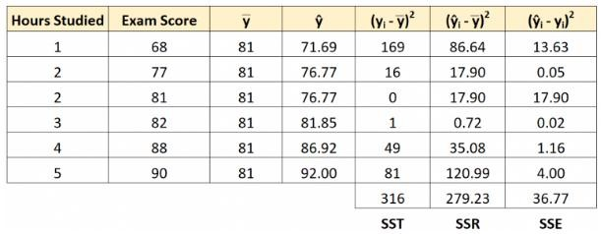

We can verify that SST = SSR + SSE

  - SST = SSR + SSE
  - 316 = 279.23 + 36.77

Adjusted R- Squared

R-squared measures the proportion of the variation in your dependent variable (Y) explained by your independent variables (X) for a linear regression model.

Adjusted R-squared adjusts the statistic based on the number of independent variables in the model. R² shows how well terms (data points) fit a curve or line. Adjusted R² also indicates how well terms fit a curve or line, but adjusts for the number of terms in a model. If you add more and more useless variables to a model, adjusted r-squared will decrease. If you add more useful variables, adjusted r-squared will increase.

Adjusted R²adj will always be less than or equal to R². You only need R² when working with samples. In other words, R² isn't necessary when you have data from an entire population.

Formula

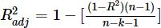

Where −

  - n = the number of points in your data sample.
  - k = the number of independent regresses, i.e. the number of variables in your model, excluding the constant.

Example

A fund has a sample R-squared value close to 0.5 and it is doubtlessly offering higher risk adjusted returns with the sample size of 50 for 5 predictors. Find Adjusted R square value.

Solution −

Sample size = 50 Number of predictor = 5 Sample R - square = 0.5.
Substitute the qualities in the equation,

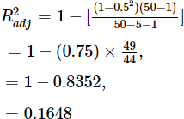

Multiple Linear Regression

Regression models are used to describe relationships between variables by fitting a line to the observed data. Regression allows you to estimate how a dependent variable changes as the independent variable(s) change.

Multiple linear regression is used to estimate the relationship between two or more independent variables and one dependent variable.

Use of multiple linear regression for:

- How strong the relationship is between two or more independent variables and one dependent variable (e.g. how rainfall, temperature, and amount of fertilizer added affect crop growth).
- The value of the dependent variable at a certain value of the independent variables (e.g. the expected yield of a crop at certain levels of rainfall, temperature, and fertilizer addition).

Assumptions of multiple linear regression

Multiple linear regression makes all of the same assumptions as simple linear regression:

Homogeneity of variance (homoscedasticity): the size of the error in our prediction doesn‘t change significantly across the values of the independent variable.

Independence of observations: the observations in the dataset were collected using statistically valid sampling methods, and there are no hidden relationships among variables.

In multiple linear regression, it is possible that some of the independent variables are actually correlated with one another, so it is important to check these before developing the regression model. If two independent variables are too highly correlated (r2 > ~0.6), then only one of them should be used in the regression model.

Normality: The data follows a normal distribution.

Linearity: the line of best fit through the data points is a straight line, rather than a curve or some sort of grouping factor.

Multiple linear regression formula

The formula for a multiple linear regression is:

• = the predicted value of the dependent variable
• = the y-intercept (value of y when all other parameters are set to 0)
• = the regression coefficient () of the first independent variable () (a.k.a. the effect that increasing the value of the independent variable has on the predicted y value)
- … = do the same for however many independent variables you are testing
• = the regression coefficient of the last independent variable
• = model error (a.k.a. how much variation there is in our estimate of )

To find the best-fit line for each independent variable, multiple linear regression calculates three things:

- The regression coefficients that lead to the smallest overall model error.
- The t statistic of the overall model.
- The associated p value (how likely it is that the t statistic would have occurred by chance if the null hypothesis of no relationship between the independent and dependent variables was true).

It then calculates the t statistic and p value for each regression coefficient in the model.

Difference between Linear Regression and Multiple Regression
Aspect | Simple Linear Regression | Multiple Linear Regression
Definition | A statistical method for finding a linear relationship between two variables. | A statistical method for finding a linear relationship between more than two variables.
Number of independent variables | One. | More than one.
Number of dependent variables | One. | One.
Equation | y = mx + b | y = b + m₁x₁ + m₂x₂ + ... + m_{n}x_{n}
Purpose | Predict the value of the dependent variable based on the value of the independent variable. | Predict the value of the dependent variable based on the values of multiple independent variables.
Assumption | Assumes a linear relationship between the independent and dependent variables. | Assumes a linear relationship between the dependent variable and multiple independent variables.
Method | Uses a simple linear regression equation to estimate the regression line. | Uses multiple linear regression equations to estimate the regression plane or hyperplane.
Complexity | Less complex. | More complex.
Interpretation | Easy to interpret. | Complex to interpret.
Data requirement | Requires fewer data. | Requires more data.
Examples | Predicting the price of a house based on its size. | Predicting the performance of a student based on their age, gender, IQ, etc.

What is P-Value?

The P-value is known as the probability value. It is defined as the probability of getting a result that is either the same or more extreme than the actual observations. The P- value is known as the level of marginal significance within the hypothesis testing that represents the probability of occurrence of the given event.
The P-value is used as an alternative to the rejection point to provide the least significance at which the null hypothesis would be rejected. If the P-value is small, then there is stronger evidence in favour of the alternative hypothesis.
P-Value is a statistical test that determines the probability of extreme results of the statistical hypothesis test, taking the Null Hypothesis to be correct.

If the P-Value is less than the significance level (usually 0.05) then your model fits the data well.

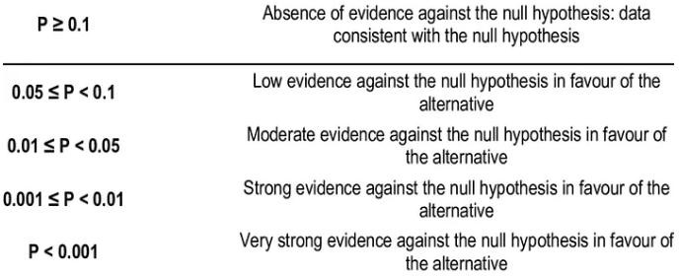

P-value always only lies between 0 and 1. The level of significance(α) is a predefined threshold that should be set by the researcher. It is generally fixed as 0.05. The formula for the calculation for P-value is:

Step 1: Find out the test static Z is Where,
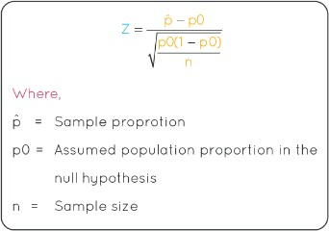

- P0= assumed population proportion in the null hypothesis
- N = sample size

Step 2: Look at the Z-table to find the corresponding level of P from the z value obtained.

Example 1: A statistician is testing the hypothesis H0: μ = 120 using the approach of alternative hypothesis Hα: μ > 120 and assuming that α = 0.05. The sample values that he took are as n =40, σ = 32.17 and x̅ = 105.37. What is the conclusion for this hypothesis?

Solution:

We know that,

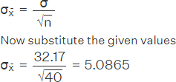

As per the test static formula, we get t = (105.37 – 120) / 5.0865
Therefore, t = -2.8762

Using the Z-Score table, finding the value of P(t > -2.8762) we get,
P (t < -2.8762) = P(t > 2.8762) = 0.003

Therefore,

If P(t > -2.8762) =1 - 0.003 =0.997

P- value =0.997 > 0.05

As the value of p > 0.05, the null hypothesis is accepted. Therefore, the null hypothesis is accepted.

Example 2: P-value is 0.3105. If the level of significance is 5%, find if we can reject the null hypothesis.

Solution: Looking at the P-value table, the p-value of 0.3105 is greater than the level of significance of 0.05 (5%), we fail to reject the null hypothesis.

Example 3: P-value is 0.0219. If the level of significance is 5%, find if we can reject the null hypothesis.

Solution: Looking at the P-value table, the p-value of 0.0219 is less than the level of significance of 0.05, we reject the null hypothesis.

Summary of Inferential Statistics

Inferential statistics is a branch of statistics that makes the use of various analytical tools to draw inferences about the population data from sample data. Apart from inferential statistics, descriptive statistics forms another branch of statistics. Inferential statistics help to draw conclusions about the population while descriptive statistics summarizes the features of the data set.

There are two main types of inferential statistics - hypothesis testing and regression analysis. The samples chosen in inferential statistics need to be representative of the entire population. In this article, we will learn more about inferential statistics, its types, examples, and see the important formulas.

What is Inferential Statistics?

Inferential statistics helps to develop a good understanding of the population data by analyzing the samples obtained from it. It helps in making generalizations about the population by using various analytical tests and tools. In order to pick out random samples that will represent the population accurately many sampling techniques are used. Some of the important methods are simple random sampling, stratified sampling, cluster sampling, and systematic sampling techniques.

Inferential Statistics Definition

Inferential statistics can be defined as a field of statistics that uses analytical tools for drawing conclusions about a population by examining random samples. The goal of inferential statistics is to make generalizations about a population. In inferential statistics, a statistic is taken from the sample data (e.g., the sample mean) that used to make inferences about the population parameter (e.g., the population mean).

Inferential Statistics:

Statistics is the science of collecting, organizing, summarizing, analyzing, and interpreting information.
Inferential statistics is a branch of statistics that involves using sample data to make inferences or draw conclusions about a larger population from which the sample was drawn. We can understand Explanation of Definition in Following Diagram
It allows us to generalize findings from a limited set of observations to a broader context. Here are key points about inferential statistics:

Population and Sample:
- In inferential statistics, we have a population, which is the entire group of individuals or items of interest.
- We often work with a sample, which is a subset of the population. The sample is used to make inferences about the population.

Purpose:
- The primary purpose of inferential statistics is to make predictions, test hypotheses, and assess relationships or differences within populations.

Statistical Inference:
- Statistical inference involves drawing conclusions or making predictions about a population based on sample data.
- It uses probability theory and mathematical models to quantify the uncertainty associated with these conclusions.

Hypothesis Testing:
- Hypothesis testing is a common inferential statistical technique.
- It involves formulating a null hypothesis (H0) and an alternative hypothesis (Ha) and then conducting tests to determine whether there is enough evidence to reject the null hypothesis.

Confidence Intervals:
- Confidence intervals provide a range of values within which a population parameter is likely to fall.

- They are used to quantify the level of uncertainty associated with an estimate.

Probability Distributions:
- Inferential statistics often rely on probability distributions, such as the normal distribution or t-distribution, to make predictions and perform hypothesis tests.

Sampling Methods:
- Careful sampling methods are crucial in inferential statistics. The way a sample is selected can greatly impact the validity of inferences.

Key Concepts:
- Margin of error: A measure of the uncertainty in an estimate.
- Significance level (alpha): The probability threshold used to determine statistical significance.
- P-value: The probability of observing a result as extreme as, or more extreme than, the one obtained if the null hypothesis is true.

Statistical Tests:
- Inferential statistics involve various statistical tests, including t-tests, chi-squared tests, ANOVA, regression analysis, and more.
- The choice of test depends on the research question and the type of data.

Assumptions:
- Many inferential statistical tests have underlying assumptions, such as normality of data or independence of observations. Violations of these assumptions can affect the validity of results.

Generalization:
- One of the primary goals of inferential statistics is to generalize findings from a sample to a larger population.
- The accuracy of generalization depends on the quality of the sample and the appropriateness of statistical methods.

Applications:
- Inferential statistics is used in various fields, including science, business, healthcare, social sciences, and more, to make informed decisions and draw meaningful conclusions.

Inferential statistics is a critical tool for researchers and analysts to make sense of data and make informed decisions based on limited information. It provides a framework for quantifying uncertainty and evaluating the validity of research findings.

Why do we need inferential statistics?
Inferential statistics helps us answer the following questions:
- Making inferences about a population from a sample
- Concluding whether a sample is significantly different from the population. Let‘s look at the previous example where I pointed out that the sample is different from the population as the children are more interested in sports rather than watching television.
- If adding or removing a feature from a model will help in improving it.
- If one model is significantly different from the other.
- Hypothesis Testing.

This shows us why inferential statistics is important and why it is worth investing time and effort in learning these concepts

Example: Consider the case where you are interested in the average number of hours children watch television per day. Now you know that the children in your locality on an average watch television for 1 hour per day. How do you go about finding this for all the children?
There are 2 methods you could use to calculate the results:
- Collect data about each and every child.
- Use the data we have to calculate the overall average.

The first method is extremely difficult and daunting task. The amount of effort and resources required to complete this task would be enormous.
The second method is much simpler and easier to accomplish. But there is a problem. You cannot equate the average you obtained from a limited data set to the entire population. Consider the case where the children in your locality are more interested in sports so the number of hours, they spend on television is significantly lesser than that of the overall population. How do we go about finding the population mean? This is where inferential statistics comes to our rescue.
.
. Differences between descriptive and inferential statistics:

Aspect | Descriptive Statistics | Inferential Statistics
Purpose | Summarizes and describes data. | Draws conclusions or inferences about a population based on  sample data.
Data Used | Entire dataset  (population). | Sample data (subset of the  population).
Goal | Provides insights into the data's characteristics (e.g., central tendency,  variability). | Makes predictions, tests hypotheses, and assesses relationships.

Examples | Mean, median, mode, standard deviation, range. | Confidence intervals, hypothesis tests,  regression analysis.
Population Parameter | Not used for estimation or  inference. | Often used to estimate  population parameters.
Data Presentation | Typically presented using graphs, tables, or  summary statistics. | Presented using statistical tests, estimates, and  confidence intervals.
Sample Size | Not a concern; works with the entire population. | Sample size is critical;  larger samples increase precision.
Probability Distribution | Not required; descriptive  statistics do not involve probability distributions. | Involves probability  distributions, such as the normal distribution.
Generalizability | Descriptive statistics do not generalize beyond the  data at hand. | Inferential statistics aim to generalize findings to the  broader population.
Key Techniques | Measures of central tendency, measures of dispersion, graphical  displays. | Hypothesis testing, confidence intervals, regression analysis.
Example Use Case | Calculating the average age in a survey sample. | Testing whether a new drug is effective in a larger population based on  clinical trial data.

Types of Inferential Statistics

Inferential statistics can be classified into hypothesis testing and regression analysis. Hypothesis testing also includes the use of confidence intervals to test the parameters of a population. Given below are the different types of inferential statistics.

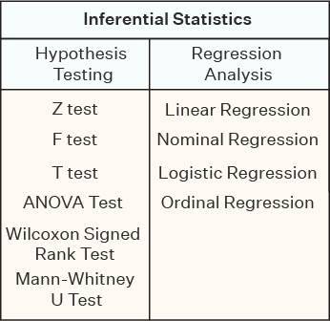

Hypothesis Testing

Hypothesis testing is a type of inferential statistics that is used to test assumptions and draw conclusions about the population from the available sample data. It involves setting up a null hypothesis and an alternative hypothesis followed by conducting a statistical test of significance. A conclusion is drawn based on the value of the test statistic, the critical value, and the confidence intervals. A hypothesis test can be left- tailed, right-tailed, and two-tailed. Given below are certain important hypothesis tests that are used in inferential statistics.

Z Test: A z test is used on data that follows a normal distribution and has a sample size greater than or equal to 30. It is used to test if the means of the sample and population

are equal when the population variance is known. The right tailed hypothesis can be set up as follows:

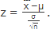
Null Hypothesis: H0 : μ=μ0 Alternate Hypothesis: H1: μ>μ0 Test Statistic:

¯X is the sample mean, μ is the population mean, σ is the population standard deviation and n is the sample size.

Decision Criteria: If the z statistic > z critical value then reject the null hypothesis.

T Test: A t test is used when the data follows a student t distribution and the sample size is lesser than 30. It is used to compare the sample and population mean when the population variance is unknown. The hypothesis test for inferential statistics is given as follows:

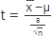
Null Hypothesis: H0 : μ=μ0 Alternate Hypothesis: H1 : μ>μ0 Test Statistics

Decision Criteria: If the t statistic > t critical value then reject the null hypothesis.

F Test: An f test is used to check if there is a difference between the variances of two samples or populations. The right tailed f hypothesis test can be set up as follows:

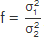
Null Hypothesis: H0 : σ21=σ22 Alternate Hypothesis: H1 : σ21>σ22 Test Statistic:

where 𝜎² is the variance of the first population and 𝜎² is the variance of the second
1 2
population.

Decision Criteria: If the f test statistic > f test critical value then reject the null hypothesis.

Confidence Interval: A confidence interval helps in estimating the parameters of a population. For example, a 95% confidence interval indicates that if a test is conducted 100 times with new samples under the same conditions then the estimate can be expected to lie within the given interval 95 times. Furthermore, a confidence interval is also useful in calculating the critical value in hypothesis testing.

Apart from these tests, other tests used in inferential statistics are the ANOVA test, Wilcoxon signed-rank test, Mann-Whitney U test, Kruskal-Wallis H test, etc.

Regression Analysis

Regression analysis is used to quantify how one variable will change with respect to another variable. There are many types of regressions available such as simple linear, multiple linear, nominal, logistic, and ordinal regression. The most commonly used regression in inferential statistics is linear regression. Linear regression checks the effect of a unit change of the independent variable in the dependent variable. Some important formulas used in inferential statistics for regression analysis are as follows:

Regression Coefficients:

The straight line equation is given as y = α+ βx, where α and β are regression coefficients.

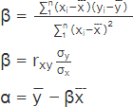

Here, 𝑥 is the mean, and σ_{x} is the standard deviation of the first data set. Similarly, 𝑦
is the mean, and σ_{y} is the standard deviation of the second data set. Inferential Statistics Examples
Inferential statistics is very useful and cost-effective as it can make inferences about the population without collecting the complete data. Some inferential statistics examples are given below:

- Suppose the mean marks of 100 students in a particular country are known. Using this sample information the mean marks of students in the country can be approximated using inferential statistics.
- Suppose a coach wants to find out how many average cartwheels sophomores at his college can do without stopping. A sample of a few students will be asked to perform cartwheels and the average will be calculated. Inferential statistics will use this data to make a conclusion regarding how many cartwheel sophomores can perform on average.

